GUI Assignment 1 Project Report

Prototyping
What is prototyping used for?
Prototyping is used to clarify requirements, test usability, and decide on workflows early in the development stages of a project. It enhances communication between developers and stakeholders, identifies design flaws and prioritises features that are important for the client and the project. (Wikipedia, 2025)
A prototype is a cheap way to test ideas, letting you validate, discard, or improve them without going all in on full development. In a student management system, a prototype could show that users have a hard time moving from the login screen to the dashboard because the instructions or the design aren't clear. Fixing issues in the prototype phase means just tweaking layouts or formatting. If found later, it could lead to a lot of coding, redesigning, and testing.
By enabling interactive feedback, it reduces development risks and costs, ensures user-centred design, and fosters end-user engagement, leading to a more polished and usable final product.

Advantages of prototyping:
- Clarifies Requirements - Helps stakeholders to visualise the system, reducing misunderstandings and confusion about the project requirements/expectations.
- Improves User Experience (UX) - Allows usability testing and refinement based on real user feedback.
- Facilitates Better Communication - Provides a reliable way of communication between developers, stakeholders, and end users.
- Supports Iterative Development - Allows changes based on feedback, leading to continuous improvement along the way.
- Saves Time and Costs - Fixing issues during prototyping is cheaper and faster than post-development corrections/changes.
- Prioritises Features - Helps stakeholders focus on essential features and de-prioritise unnecessary elements.
- Demonstrates Progress - Provides a visual way to showcase progress, keeping stakeholders aligned and engaged.

How does the prototyping approach improve the communication process between the developer and the end user?
- Prototyping cuts development costs by spotting issues and gaps early in the project, making changes cheaper to implement. In classic development models, bugs or missing requirements usually pop up late for example during coding, testing, or deployment. Fixing these problems early can lead to expensive rework, delays, and wasted resources. Prototyping reduces risk by letting developers and users work together to refine the solution before spending major resources on it. (Lonc, 2024)
- Prototypes allow instant interaction between users and devs, creating a crucial feedback loop early in the project. Users can interact with a working model early on, giving instant feedback on what’s good, what’s not, and what needs tweaks, instead of waiting for late stage testing or deployment. Fast feedback helps devs fix issues, apply suggestions, and adjust quickly, keeping the product in line with end user needs. Instant feedback boosts collaboration and empowers users. When users engage in the process, they feel heard and their input matters. (Studio, n.d.)
- Prototypes are useful for testing real user scenarios, helping developers check if the app meets practical needs before full development starts. In a student record management system, a user tests the login prototype by choosing a role (like admin or guest) and trying to navigate the interface. This interaction can show key usability issues like complex navigation, unclear error messages, or missing features for specific user roles.
- Prototyping gives stakeholders a hands-on view of the final product, connecting abstract concepts to real-world applications. A prototype is way better than static docs or specs because it shows how the app will actually look, feel, and work for both devs and users. This visualisation helps align expectations and ensures the final result meets the goals.
- Prototyping enhances user engagement and satisfaction because users and clients are actively involved in the development process. It significantly increases their sense of ownership and trust in the final product. This involvement not only makes them feel valued but also contributes to a more collaborative environment, ultimately leading to a better overall experience. This ultimately leads to a solution that aligns more closely with their specific needs and expectations, ensuring a more satisfactory product. (Team, 2024)

Login Form
Version 1 – Initial Design
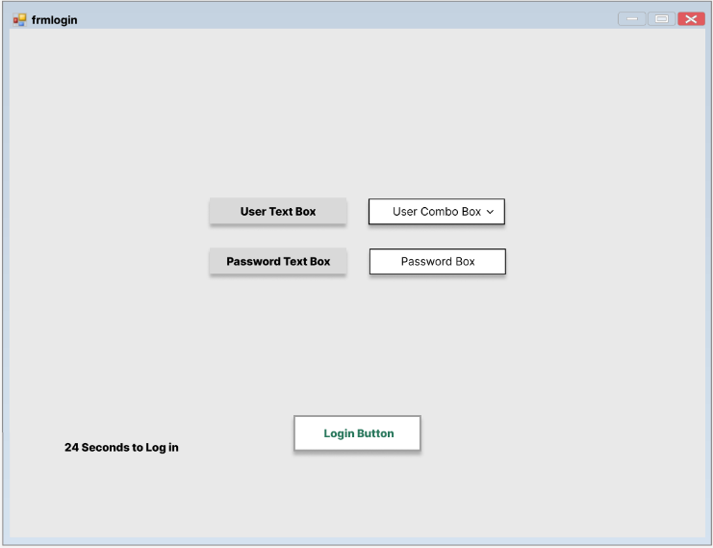

This version includes basic combo box for the usernames and a password input box plus a timer. There is also a simple design with little attention to details.

Version 2 – Redefined Design
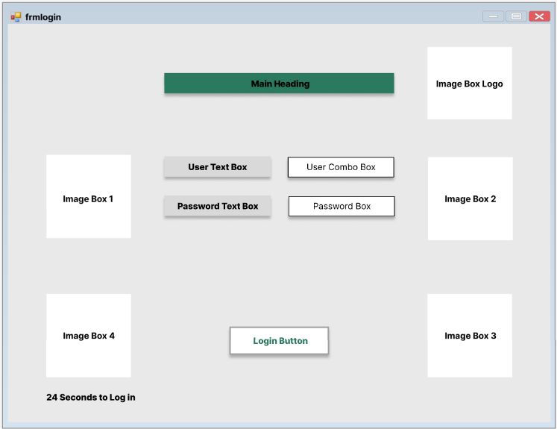

In this version placeholder images were added as well as the heading placeholder which will help the user know which screen they are on.

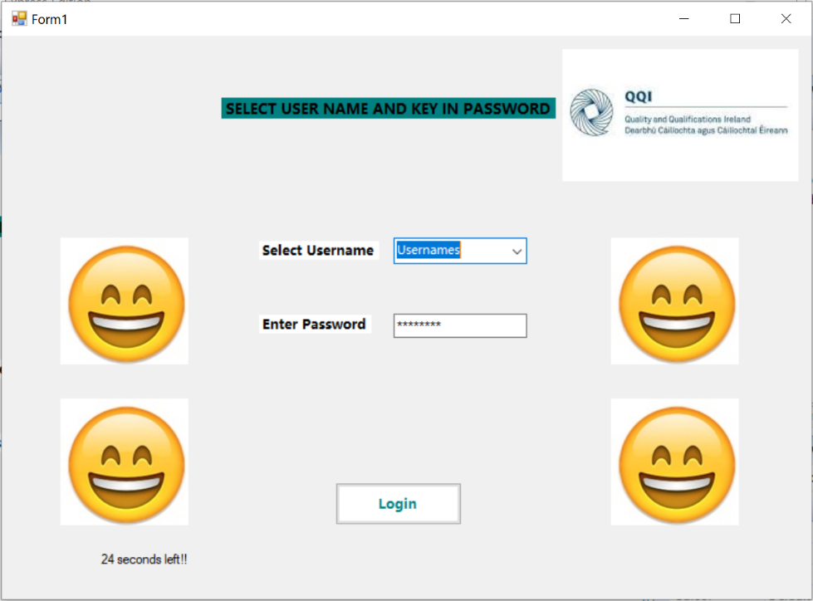
Version 3 – Final Design

This version is very similar to the final version of the form. The final images were added and are connected/synced to the timer and they will spin and disappear as the timer runs out to create an animation. The logo was also added to show the user this form is associated with the QQI.

Menu Form
Version 1 – Initial Design
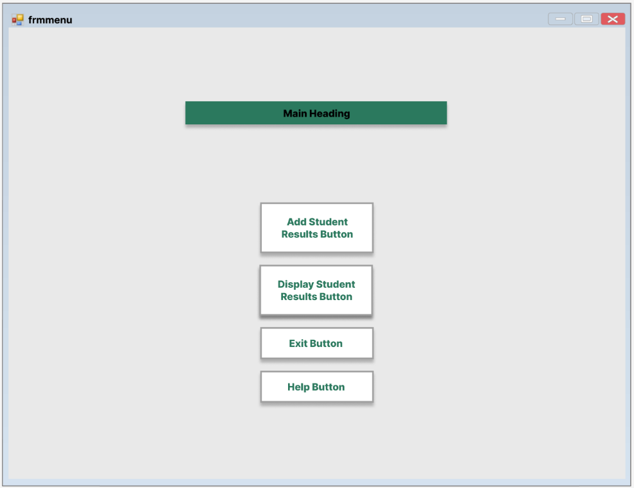

This is a rough sketch, the version includes basic button design and the main heading. The design is very simple with little attention to details.

Version 2 – Redefined Design
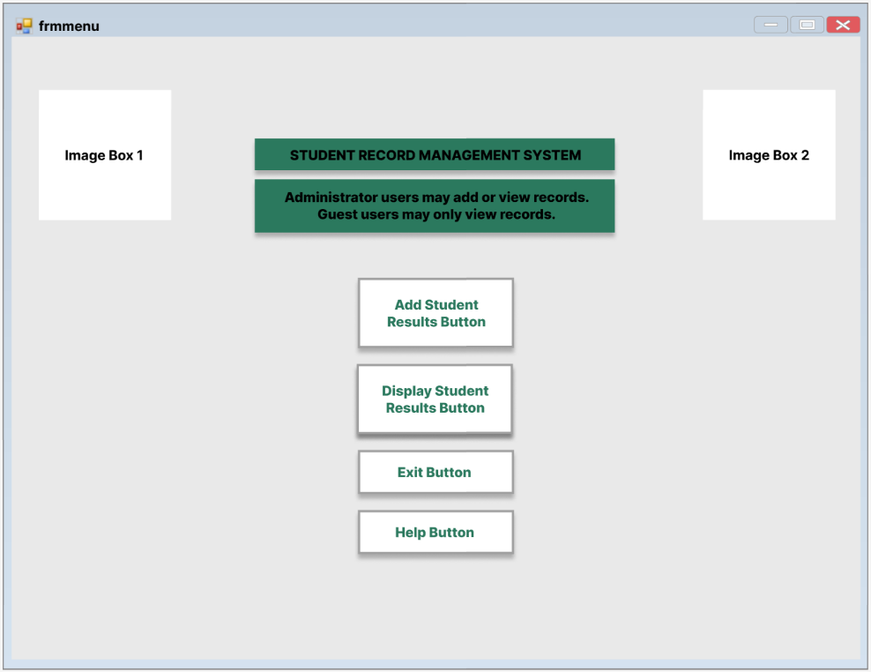

This is a rough sketch, the version includes basic button design and the main heading text box. The design is very simple with little attention to details.

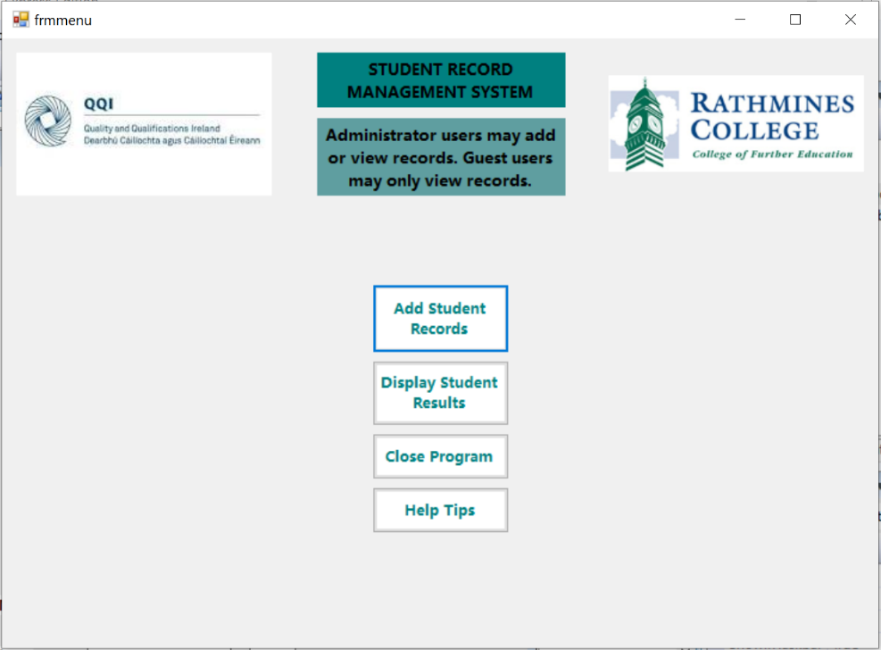
Version 3 – Finished Design
This version is very similar to the final version of the form. The final images were added to represent the Rathmines College and a logo to show the user this form is associated with the QQI. The final headings were added as well as proper buttons and their naming. The buttons were also linked with the appropriate form links.

Add Records Form
Version 1 – Initial Design
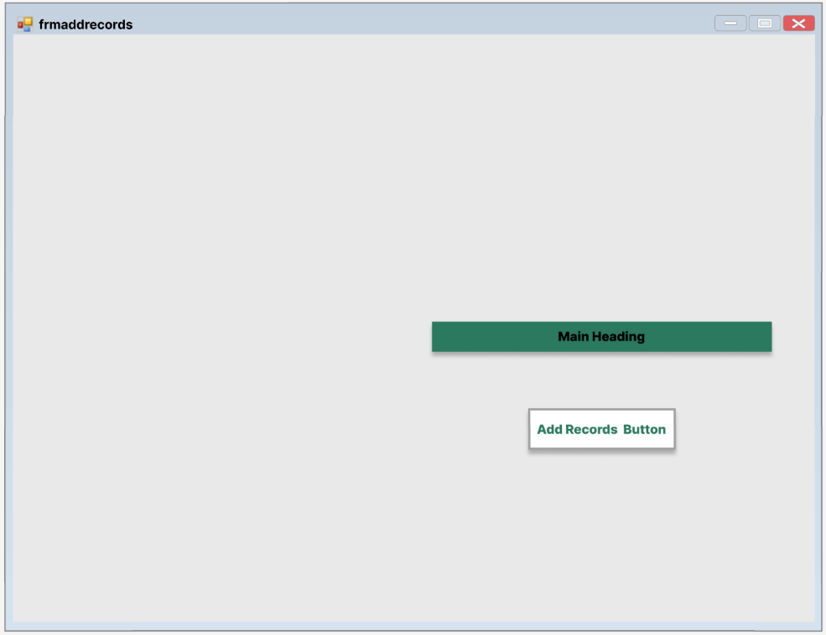

This is a rough sketch, the version includes a basic button design and the main heading. The design is very simple with little attention to details.

Version 2 – Redefined Design
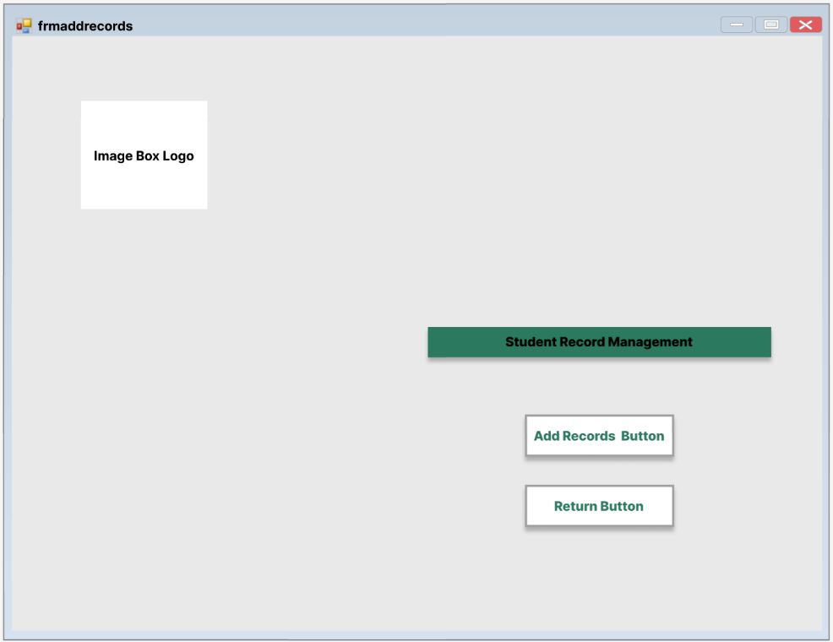

This is a rough sketch, the version includes basic button designs and the main heading text box. The design is very simple with little attention to details. An image box was also added as a placeholder for the Rathmines logo.

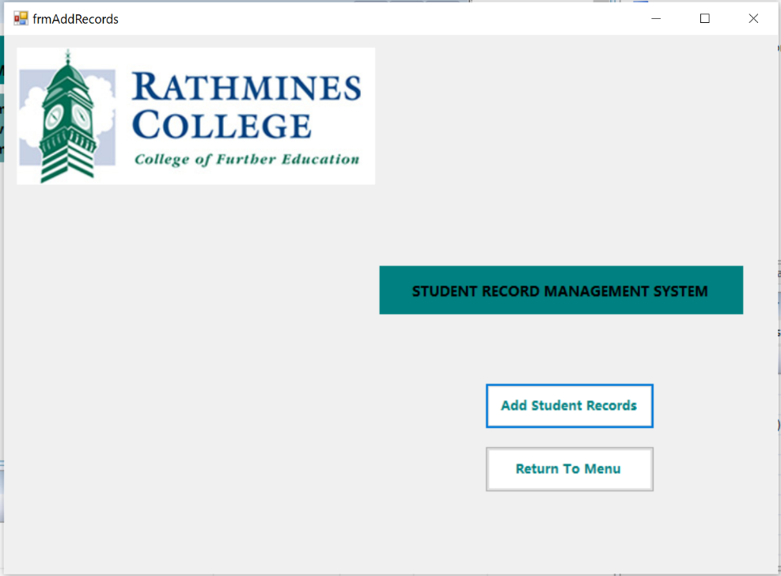
Version 3 – Finished Design

This version is very similar to the final version of the form. The final logo was added to represent the Rathmines College. The final heading was added as well as proper buttons and their naming. The buttons were also linked with the appropriate form links.

Help Form
Version 1 – Initial Design
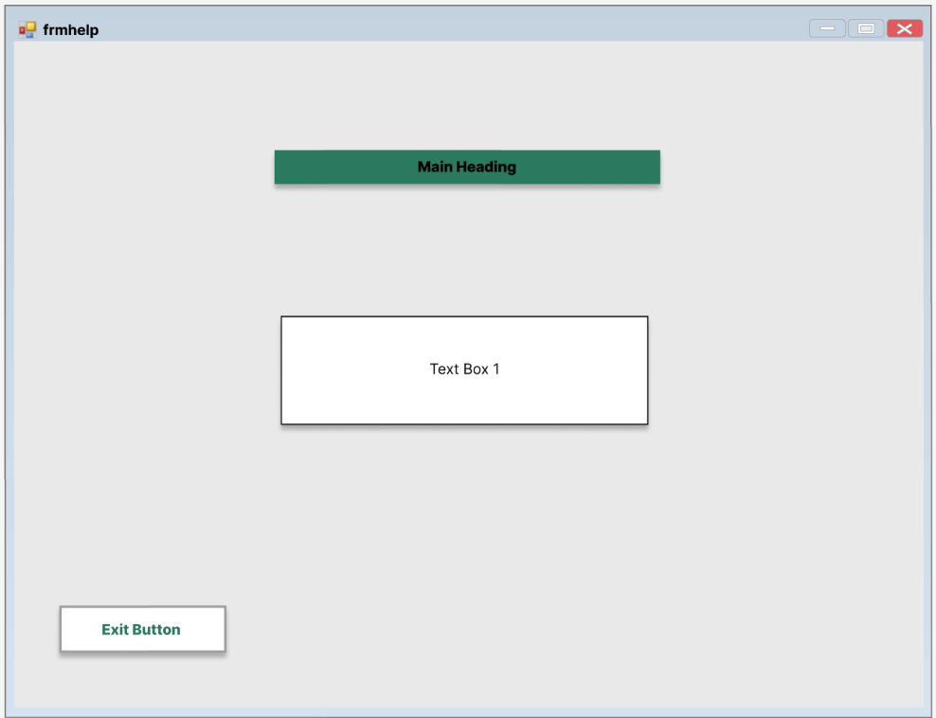

This is a rough sketch, the version includes a basic button design, the main heading and a text box. The design is very simple with little attention to details.

Version 2 – Redefined Design
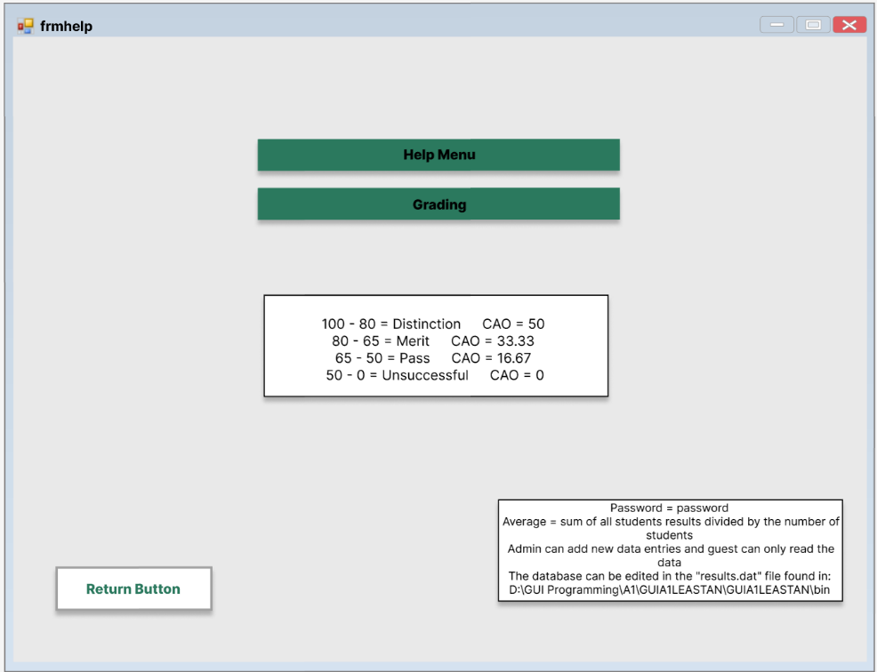

This is a rough sketch, the version includes basic button designs, the headings and text boxes. The design is very simple with little attention to details. The first text box includes basic data on grading and the second one includes tips on how to use the form.

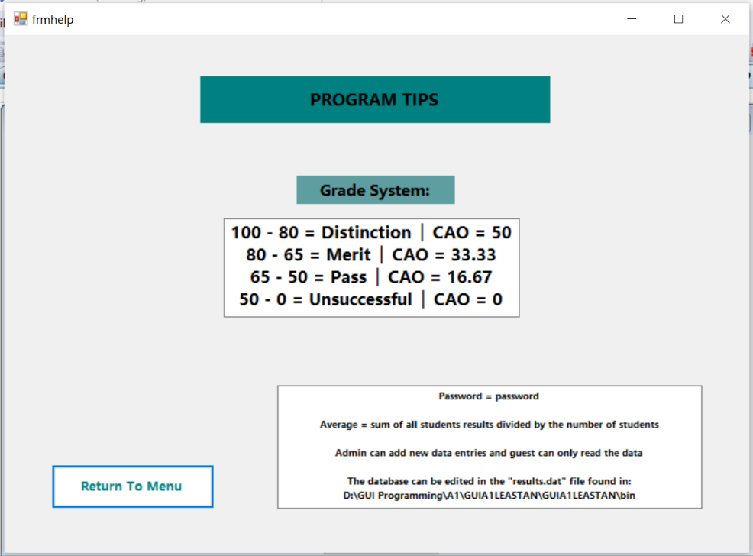
Version 3 – Finished Design

This version is very similar to the final version of the form. The final headings were added as well as a return button which is linked with the appropriate form link. Formatting was added to make the overall appearance of the form more appealing.

Help Form
Version 1 – Initial Design
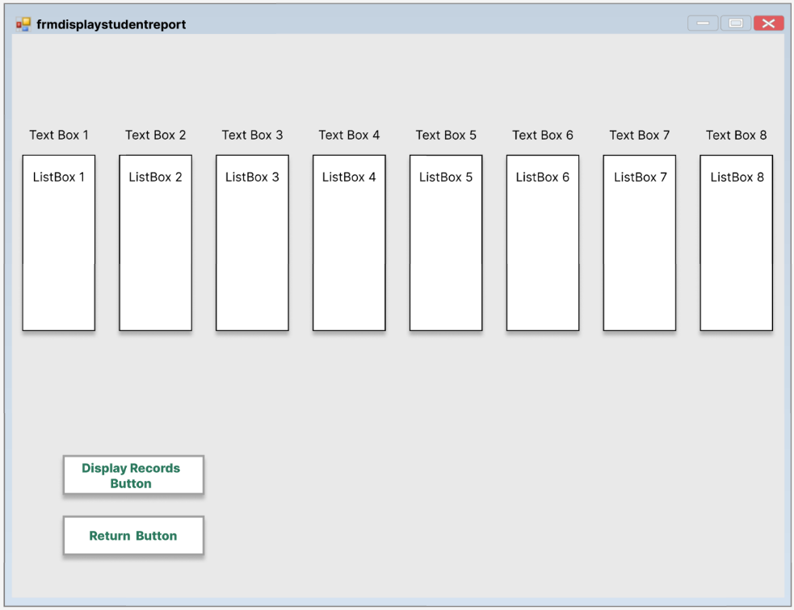

This is a rough sketch, the version includes a basic button design, text boxes and list boxes. The design is very simple with little attention to details.

Version 2 – Redefined Design
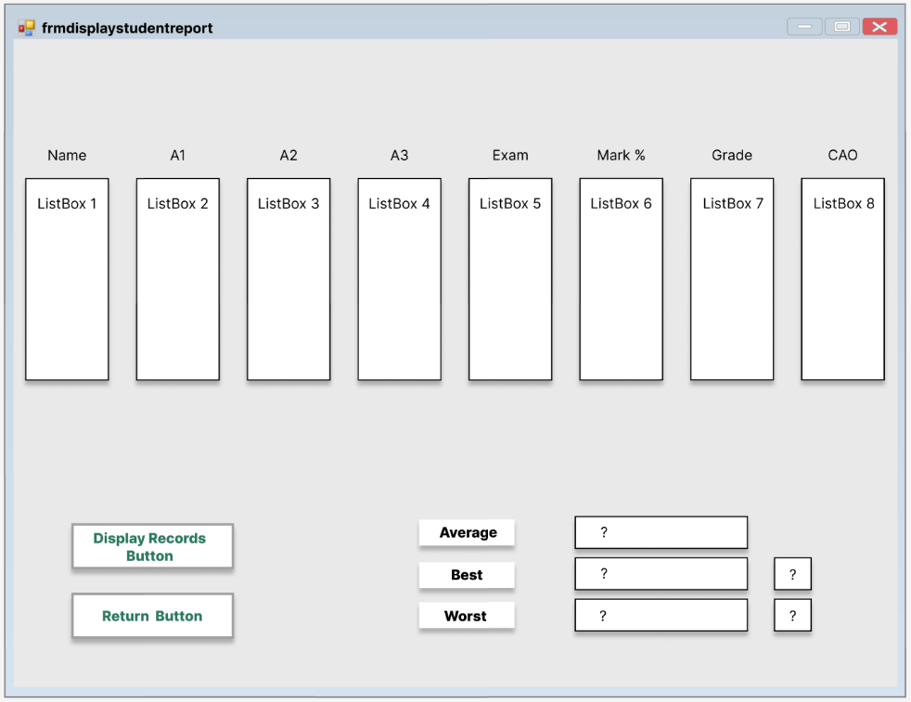

This is still a rough sketch of the form with no final touches. The text boxes are being used for headings of the list boxes. The text boxes for average, best and worst results were added as well as the corresponding output boxes to display the data.

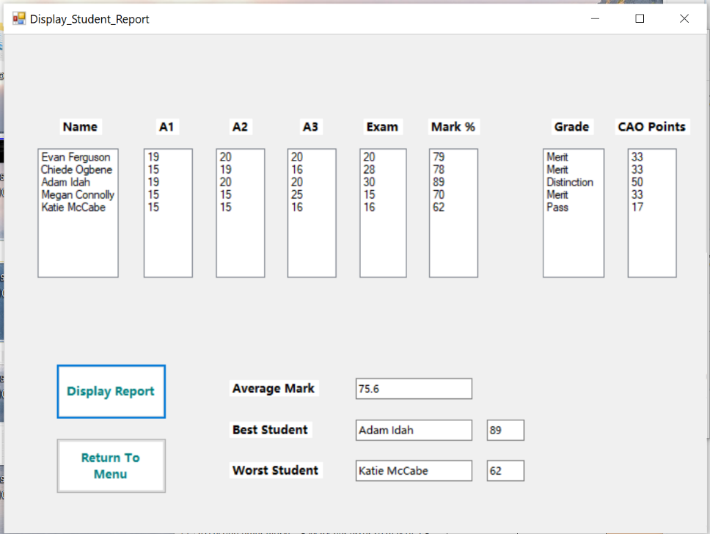
Version 3 – Finished Design

This version is very similar to the final version of the form. The buttons are now linked with the appropriate form links. Formatting was added to make the overall appearance of the form more appealing. The data is also being displayed in the appropriate list boxes as well as other data like average, best and worst marks.

Bibliography
Lonc, J., 2024. What is Prototyping in Software Development (and Why It’s Important). [Online]
Available at: https://sparkbusinessworks.com/blog/prototyping-in-software-development/
[Accessed 11 December 2025].
Studio, A., n.d. Better communication during the development process through prototyping. [Online]
Available at: https://aw-studio.de/en/blog/better-communication-during-the-development-process-through-prototyping?utm_source=chatgpt.com
[Accessed 12 December 2024].
Team, A. C. &. M. R., 2024. Prototyping for user feedback in software development. [Online]
Available at: https://moldstud.com/articles/p-prototyping-for-user-feedback-in-software-development?utm_source=chatgpt.com
[Accessed 12 December 2025].
Wikipedia, 2025. Software prototyping. [Online]
Available at: https://en.wikipedia.org/wiki/Software_prototyping?utm_source=chatgpt.com
[Accessed 10 December 2024].

